1.

1.1) Program to remove all repeated elements from an array 1.2) Write a Java program to find the common elements between two arrays of integers.

2.

2. 1) Java Program to Count Number of Duplicate Words in String

2.2) How to Check if the String Contains 'e' in umbrella

3.

3.1)Java Program to Reverse a String.

3.2) Write a Java program to check that String is palindrome or not.

4. A Company manufactures Vehicles, which could be a Helicopter, a Car, or a Train depending on the customer’s demand. Each Vehicle instance has a method called move, which prints on the console the nature of movement of the vehicle. For example, the Helicopter Flies in Air, the Car Drives on Road and the Train Runs on Track. Write a program that accepts input from the user on the kind of vehicle the user wants to order, and the system should print out nature of movement. Implement all Java coding best practices to implement this program.

5. We have to calculate the percentage of marks obtained in three subjects (each out of 100) by student A and in four subjects (each out of 100) by student B. Create an abstract class 'Marks' with an abstract method 'getPercentage'. It is inherited by two other classes 'A' and 'B' each having a method with the same name which returns the percentage of the students. The constructor of student A takes the marks in three subjects as its parameters and the marks in four subjects as its parameters for student B. Create an object for eac of the two classes and print the percentage of marks for both the students.

6. Write the following code in your editor below:  
A class named Arithmetic with a method named add that takes 2 integers as parameters and returns an integer denoting their sum.  
A class named Adder that inherits from a superclass named Arithmetic. The main method in the Tester class should print the following: SAMPLE O/P:**My superclass is: Arithmetic  
42 13 20**

**7.** You are required to compute the power of a number by implementing a calculator. Create a class My Calculator which consists of a single method long power (int, int). This method takes two integers n and p, as parameters and finds (n)p. If either or is negative, then the method must throw an exception which says " n or p should not be negative”. Also, if both and are zero, then the method must throw an exception which says "n or p should not be negative”.

8. You are given a phone book that consists of people's names and their phone number. After that you will be given some person's name as query. For each query, print the phone number of that person. Use HashMap to implement it.The first line will have an integer denoting the number of entries in the phone book. Each entry consists of two lines: a name and the corresponding phone number.  
After these, there will be some queries. Each query will contain a person's name. Read the queries until end-of-file.  
Constraints:  
A person's name consists of only lower-case English letters and it may be in the format 'first-name last-name' or in the format 'first-name'. Each phone number has exactly 8 digits without any leading zeros.For each case, print "Not found" if the person has no entry in the phone book. Otherwise, print the person's name and phone number.

9. 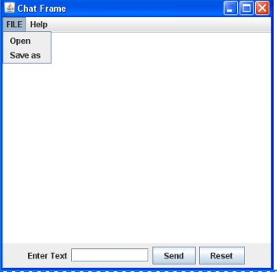

10. 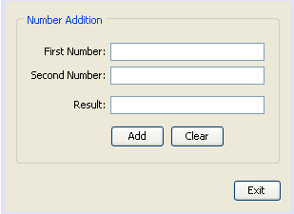

11.

11.1) Write a Java program that takes a number as input and prints its multiplication table up to 10. Test Data:  
Input a number: 8  
Expected Output :  
8 x 1 = 8  
8 x 2 = 16  
8 x 3 = 24  
...  
8 x 10 = 80

11.2) Write a java program to check that given number is prime or not.

12. Write a Java program to display the pattern like a diamond.  
Input number of rows (half of the diamond) :7 Expected Output :  
  
  
*   
***   
*****   
*******   
*********   
***********   
*************   
***********   
*********   
*******   
*****   
***   
*

13.

13.1) Write Java Program to find the transpose of a given matrix .

13.2) Write Java Program to find the number of the words in the given text file.

14. 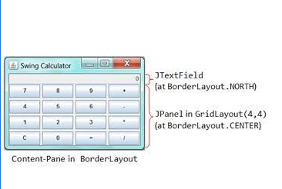

15. Write a Java Program to iterate ArrayList using for-loop, iterator, and advance for-loop. Insert 3 Array List.Input 20 30 40Output:  
  
  
iterator Loop:  
20  
30  
40  
Advanced For Loop:  
20  
30  
40  
For Loop:  
20  
30  
40

16. Write a Java Program to count the number of words in a string using HashMap.Output:  
Input :Enter String: "This this is is done by Saket Saket";  
{Saket=2, by=1, this=1, This=1, is=2, done=1}

17. Write a program to read 10 string from console and then print the sorted strings on console (Use String Class).2) combine two string 3)reverse first string nd dispaly it .

18. Write a program to implement following inheritance. Accept data for 5 persons and display the name of employee having salary greater than 5000.  
  
Class Name: Person  
Member variables:  
Name, age  
  
Class Name: Employee  
Member variables:  
Designation, salary

19. Implementing “Multiple Inheritance”. Create a two interfaces Account containing methods set() and display() And interface Person containing methods store() and disp(). Derive a class Customer from Person and Account. Accept the name, account number, balance and display all the information related to account along with the interest.

20. "Write a program, to implement the following hierarchy. Displays information of each class the rectangle represents the classes. The classes Movie and MusicVideo inherits all the members of the class VideoTape.  
"

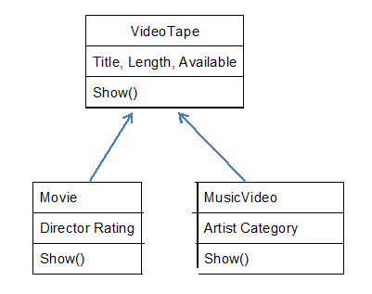

21. Write a Java program to create a class called "Student" with a name, grade, and courses attributes, and methods to add and remove courses.

22. Write a Java program to create a class known as Person with methods called getFirstName() and getLastName(). Create a subclass called Employee that adds a new method named getEmployeeId() and overrides the getLastName() method to include the employee's job title.

23. Write a Java program to find the length of the longest consecutive elements sequence from an unsorted array of integers.  
Sample array: [49, 1, 3, 200, 2, 4, 70, 5]  
The longest consecutive elements sequence is [1, 2, 3, 4, 5], therefore the program will return its length 5.

24. Create a class Student with attributes roll no, name, age and course. Initialize values through parameterized constructor. If age of student is not in between 15 and 21 then generate user-defined exception "AgeNotWithinRangeException". If name contains numbers or special symbols raise exception "NameNotValidException". Define the two exception classes.

25. 